|  |  |  |  |  |  |  |
| --- | --- | --- | --- | --- | --- | --- |
| VILNIAUS KOLEGIJA  UNIVERSITY OF APPLIED SCIENCES  FACULTY OF ELECTRONICS AND INFORMATICS  Image result for viko logo | | |  | | | VILNIUS COLLEGE  Image result for viko logoFACULTY OF ELECTRONICS AND INFORMATICS |
|  | | |  | | |  |
| **SOFTWARE DEVELOPMENT MANAGEMENT** | | |  | | | **INTRODUCTION TO INFORMATICS** |
| PRACTICAL ASSIGNMENT  PROJECT WORK  6531BX028 PI18E | | |  | | | PRACTICAL ASSIGNMENT  SPOTIFY USER MANUAL  6531BX028 PI18E |
| STUDENT | DŽIUGAS PEČIULEVIČIUS  EDITA KOMAROVA | STUDENT | | DŽIUGAS PEČIULEVIČIUS |
| (SIGNATURE)  2/25/2021 | | |  | | | LECTURER |
| LECTURER | ASTA DANILEVIČIŪTĖ | (SIGNATURE)  10/17/2018 | | VIRGILIJUS KUKLIERIUS |
| (SIGNATURE)  2/25/2021 | | |  | | | 2018 |

2021

Table of Contents

1. PROJECT IDEA, GOAL AND SCOPE 3

**1.1.** **Idea** 3

**1.2.** **Goal** 3

**1.3.** **Scope** 3

**1.4.** **Stakeholders** 3

**1.5.** **Implementation location and time** 3

2. PROJECT SCHEDULE AND BUDGET 4

**2.1.** **Work breakdown structure (WBS)** 4

**2.2.** **Network Diagram** 4

**2.3.** **Project tasks, their duration and dependencies** 4

**2.4.** **Material resources and their costs** 5

**2.5.** **Human resources, payment rates and methods** 5

**2.6.** **Fixed costs** 6

**2.7.** **Resources assigned to project tasks** 6

**2.8.** **Project schedule** 7

**2.9.** **Project budget** 7

3. PROJECT FUNDING SOURCES. 7

**3.1. Determine project funding sources.** 7

**3.2. Determine funding scope.** 8

4. PROJECT RISKS 8

**4.1. Identify and analyse the project risks.** 8

**4.2. Determine risk reduction measures.** 9

5. QUALITY MANAGEMENT 9

**5.1. Determine project quality management.** 9

6. PROJECT COMMUNICATION MANAGEMENT 9

7.PROJECT SWOT ANALYSIS 10

BIBLIOGRAPHY 11

# PROJECT IDEA, GOAL AND SCOPE

## **Idea**

Project idea would be a clothing e-commerce shop.

## **Goal**

To create ecommerce website that provides clothes and quick & easy checkout for its clients

## **Scope**

To create an ecommerce shop meets customer needs:

* Desing UI components for all the pages of the project.
* Develop user profile and its info.
* Develop cart and checkout logic.
* Implement admin panel to show all the administrator related data.
* Test application components, pages and routes.
* Test cart, state and review functionality.
* Deploy the application on Heroku.

## **Stakeholders**

* Project owner.
* Customers.
* Team members.
* Sellers.

## **Implementation location and time**

2021, Vilnius University of Applied Sciences, using virtual tools like MS Teams.

# PROJECT SCHEDULE AND BUDGET

## **Work breakdown structure (WBS)**

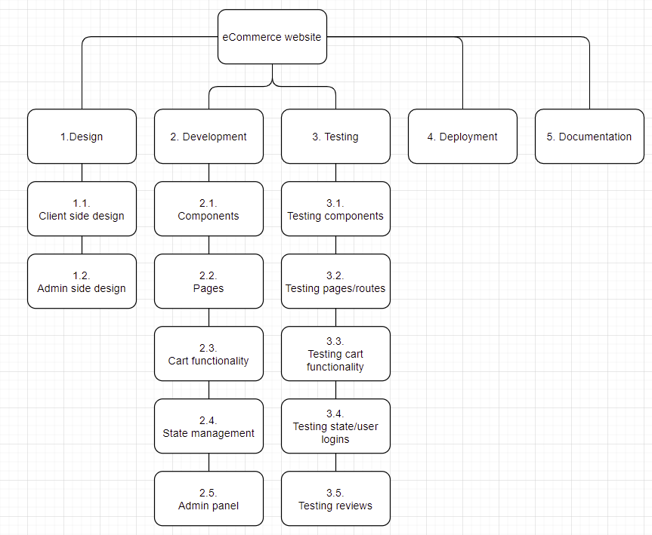

Figure 1 – WBS

Basic work breakdown structure (WBS) for the project that consists of 5 parts: design, development, testing, deployment, documentation.

## **Network Diagram**

## **Project tasks, their duration and dependencies**

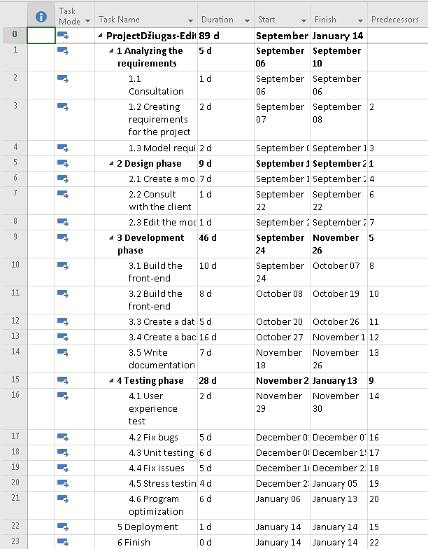

Figure 2 - Project tasks, their duration and dependencies

Project goals created using MS Project software.

## **Material resources and their costs**

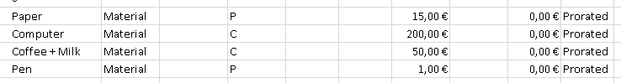

Figure 3 - Material resources

All the material resources and their costs.

## **Human resources, payment rates and methods**

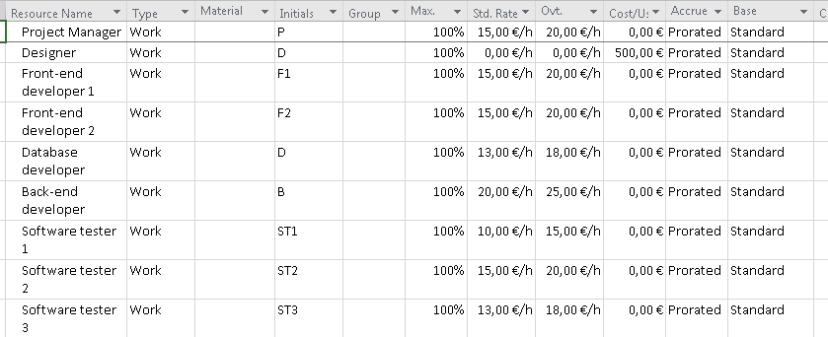

Figure 4 - Human resources

Human resources and their rates. There are total of 9 people employed.

1. Project manager – 15euro/h and 20euro/h overtime.
2. Designer – 500 euros for the entire project.
3. Front-end developer 1 - 15euro/h and 20euro/h overtime.
4. Front-end developer 2 - 15euro/h and 20euro/h overtime.
5. Database developer - 13euro/h and 18euro/h overtime.
6. Back-end developer - 20euro/h and 25euro/h overtime.
7. Software tester 1 - 10euro/h and 15euro/h overtime.
8. Software tester 2 - 15euro/h and 20euro/h overtime.
9. Software tester 3 - 13euro/h and 18euro/h overtime.

## **Fixed costs**

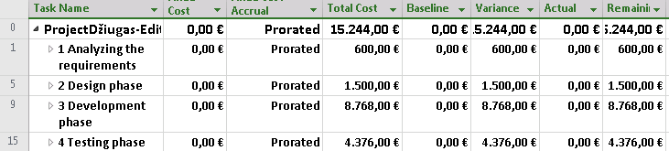

Figure 5- Fixed costs

The most budget was spent on development of the application. On the other hand, the least spent on the project was on the requirement phase.

## **Resources assigned to project tasks**

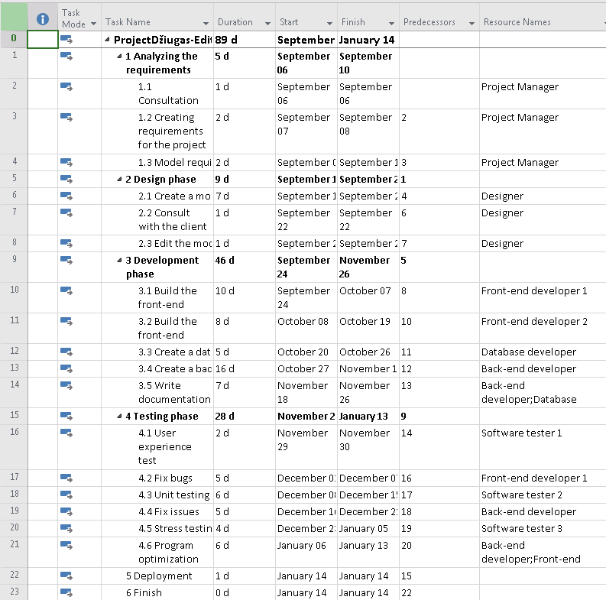

Figure 6 - project tasks with resources

Table of tasks which shows task duration, its finish and start dates, resources associated with. Total project duration can be seen on at the top of the table which is 89 days.

## **Project schedule**

In the Figure 7 it’s displayed the critical path of the project and the workers that are assigned to the task.

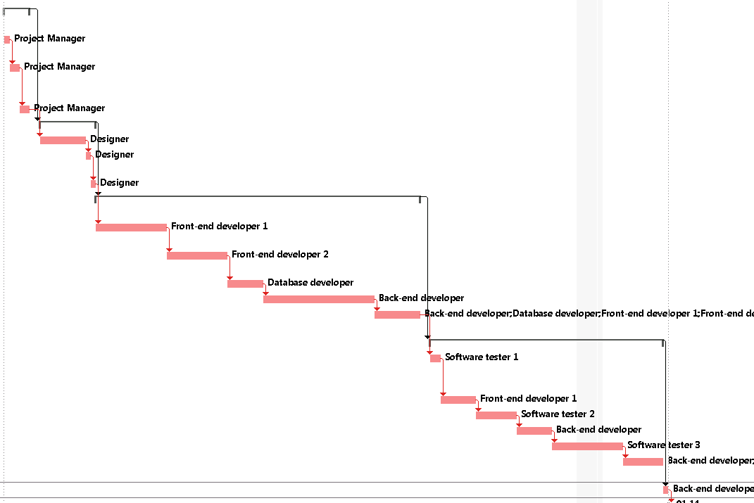

Figure 7- Project schedule

## **Project budget**

Overall the project budget is 15,244€.

# 3. PROJECT FUNDING SOURCES.

## **3.1. Determine project funding sources.**

1. Loan - generally have higher rates of interest and are less flexible as payments need to be made for a pre-agreed amount and at a pre-agreed time. Loans can be repaid in stages or at the end of the loan period.
2. Business Angels- These are private investors who invest directly in a company in exchange for an equity stake and perhaps a place on the board.
3. Retained profits- Not all profits are distributed to shareholders: the company retains a proportion as reserves.

## **3.2. Determine funding scope.**

1. Materials – materials such paper and pen will be used during the project’s timeline.
2. Human resources- Project managers, developers, testers will be paid based on the number of hours they spent working on the project.
3. Contractual workers – Designers who will be given a fixed price of the work they have done.
4. Licenses – licenses are needed for hosting database and website.

# 4. PROJECT RISKS

## **4.1. Identify and analyse the project risks.**

The project risks include like cost risks, project purpose and needs are not defined, project schedule is not clearly defined or understood, no control over staff, unplanned work that must be done, lack of communication, project conflicts not resolved in timely manner and theft of materials. The probablity of risks are show on Table 1.

Table 1 - table of risk factors

|  |  |  |  |  |  |  |  |
| --- | --- | --- | --- | --- | --- | --- | --- |
| **No** | **Task name** | **Risk name** | | Probability  **(P, 1-10)** | | **Impact**  **(I, 1-10)** | **Score**  **(P*I)** |
| 1. | Cost risks | The project can get too expensive | | 6 | | 8 | 48 |
| 2. | Project purpose and need is not well-defined | This could lead to misunderstandings and that would impact total project duration. | | 4 | | 4 | 16 |
| 3. | Project schedule is not clearly defined or understood | This could impact project duration | | 6 | | 6 | 36 |
| 4. | No control over staff | This could lead to decrease in project quality and its duration | | 4 | | 10 | 40 |
| 5. | Unplanned work that has to be done. | This would increase the duration of the project | | 5 | | 10 | 50 |
| 6. | Lack of communication, causing lack of clarity and confusion | | Lack of communication could reduce the quality of the project and its duration | | 6 | 10 | 60 |
| 7. | Project conflicts not resolved in a timely manner. | | Bugs that are not resolved on time could push back other deadlines that need to be met. | | 7 | 10 | 70 |
| 8. | Theft of materials, intellectual property or equipment. | Theft of the property could cause company a lot of problems. This would not just push back the deadline itself, but would also need to cover new equipment expenses. | | 2 | | 10 | 20 |

## **4.2. Determine risk reduction measures.**

1. To reduce the cost of material, we will re-use the material. To reduce the cost of the project, we should cheaper software.
2. We should do meetings and talk over every single little bit of things.
3. Then use proper software, define the project schedule properly that everyone understands.
4. Pay them higher salaries. Or fire them if they keep misbehaving.
5. Should have some time allocated between deadlines to finish those unexpected tasks.
6. Have some more time allocated for these kinds of conflicts.
7. Always be prepared for these kinds of thefts and have proper insurance.

# 5. QUALITY MANAGEMENT

## **5.1. Determine project quality management.**

1. Consultation with the client – there will be consultation with the client to ensure that the client is satisfied with the requirement, design and result.
2. Meetings – in the meeting project manager will have a chance to inspect the work.
3. Testing – the project will be tested to ensure that website is going to work very smoothly.

# 6. PROJECT COMMUNICATION MANAGEMENT

# Project communication management will contain project status report where project team will review the potential status and delays. There will be also Team standup where each team member will discuss what they managed to do that day. The project communication management will also contain Prototype review where the prototype will be shown to the client and discuss the changes that are needed to make. There will be task progress update that will be updated daily.

Table 2- Communication management plan

|  |  |  |  |
| --- | --- | --- | --- |
| **Communication** | **Frequency** | **Goal** | **Audience** |
| Project status report. | Weekly | Review project status and discuss potential status and delays. | Project team and client. |
| Team standup | Daily | Discuss what each team did yesterday and what they’ll do today. | Project team |
| Prototype review | At milestone | Show prototype to the client and discuss changes that need to be made. | Project manager, designer and client. |
| Task progress update | Daily | Share daily progress made on tasks | Project team |

# 7.PROJECT SWOT ANALYSIS

Strengths:

1. Low cost of structure
2. Optimized website
3. More focused on customer’s satisfaction
4. Strong brand image.
5. Online presence.

Weaknesses:

1.E-commerce website could be easily replicated.

2.Free shipping increasing cost.

3.Poor rankings for commercial keywords.

1. Preference of customers visiting shop personally.

Opportunities:

1. Pandemic.
2. Increase of online shoppers.
3. Exponential growth
4. Million products to choose from.

Threats:

1. Rising competition.
2. Cyber security threat.
3. Low entry barriers of the industry.
4. Government legislation.

# BIBLIOGRAPHY

1.Management, P. and Funding, P., 2008. *Project Funding - sources of finance for projects and programmes*. [online] Stakeholdermap.com. Available at: <https://www.stakeholdermap.com/project-management/project-funding.html> [Accessed 16 March 2021].

2.MacKay, J., 2020. *7 Steps to Write a Risk Management Plan For Your Next Project (With Free Temp... | Planio*. [online] Planio. Available at: <https://plan.io/blog/risk-management/> [Accessed 16 March 2021].

3.Guru99.com. 2017. *Quality Management Plan Template & Sample Project Example*. [online] Available at: <https://www.guru99.com/quality-management-plan-template.html> [Accessed 16 March 2021].

4. Semczuk, N., 2021. *Project Communication Plan Examples & How To Make One - The Digital Project Manager*. [online] The Digital Project Manager. Available at: <https://thedigitalprojectmanager.com/how-write-project-communication-plan/> [Accessed 16 March 2021].

5.Bush, T., 2019. *SWOT Analysis of the eCommerce Industry*. [online] PESTLE Analysis. Available at: <https://pestleanalysis.com/swot-analysis-of-ecommerce-industry/> [Accessed 16 March 2021].